Project proposal: HOtel Management

Akshith Ragukumar

Liberty University

12/8/2024

**Project: Hotel management**

Provided SQL code inside the source folder for database

**Project Description:**

This hotel management application provides users and administrators with essential functionalities for hotel room booking, customer support, and administrative management. Users can log in to check the room availability, book rooms, check confirmation, submit support tickets, and write reviews. Administrators can also monitor room availability, manage support tickets, and handle reviews, thus making hotel operations more efficient and user-friendly. This documentation provides a structured overview of each class and its attributes.

**Requirements:**

* **User authentication**: Users must log in to access the application. If login fails, an error message will be displayed, and the users can retry. Admins and regular users will have different access permissions.
* **User homepage features**: Regular users can check room availability, submit support requests, leave reviews, and log out. Room availability is displayed by default, allowing all users to book available rooms after confirmation and the users can see if their booking is confirmed or not.
* **Room booking:** Users must be able to check availability, and book rooms. A booking confirmation message should be displayed once the reservation is successful.
* **Support requests:** Regular users can create support requests, including their details like name, email, and message. Each request generates a unique ticket number that is displayed to the user.
* **Review**: Users can submit reviews with comments. A confirmation message will be displayed after successful submission.
* **Admin access:** Admins have access to manage support requests and rooms. They can view and resolve support tickets and add or remove rooms.

**Activity Diagram:**

An activity diagram has been created showing the proposed logic and workflow for the hotel management application.

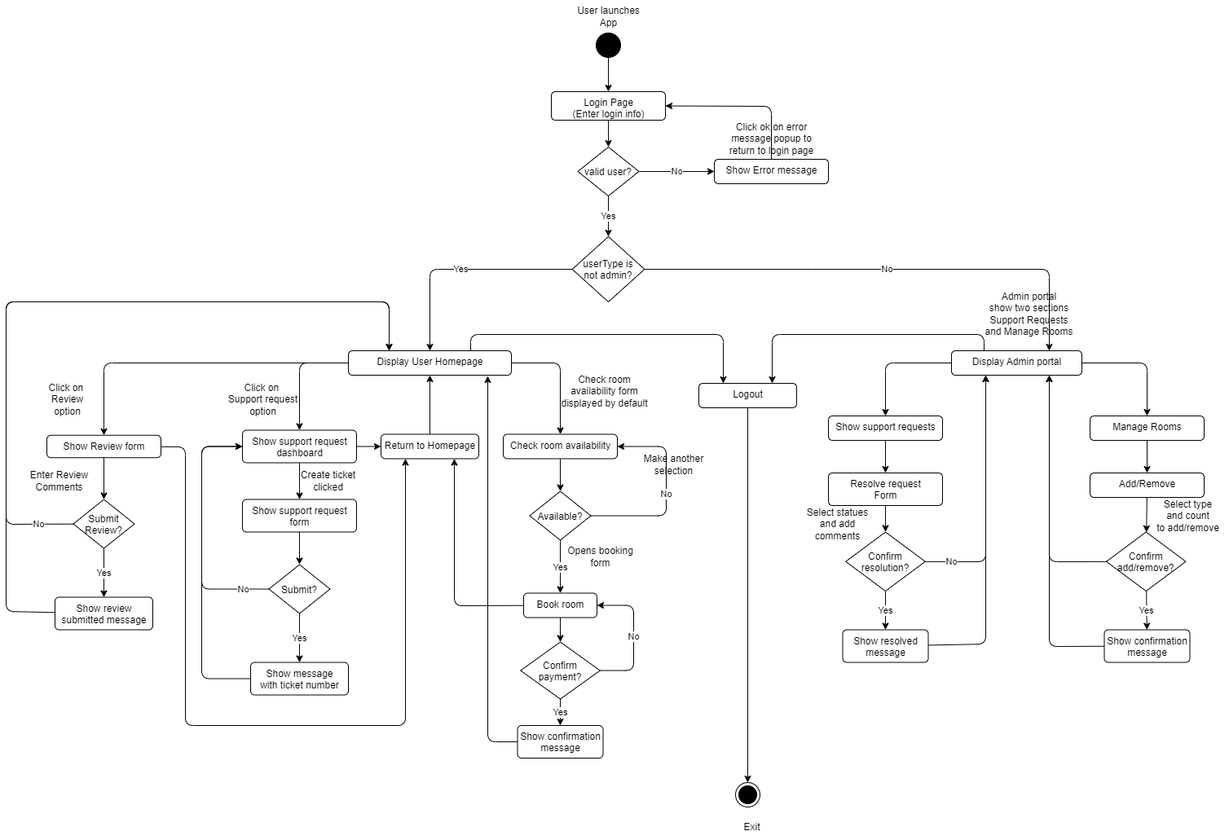

**Class List:**

1. **User Class**

* Attributes: User ID, Email, Name, Password, User Type

1. **Room Class**

* Attributes: Room ID, Type, Total Rooms, Available Rooms

1. **Booking Class**

* Attributes: Booking ID, User ID, Room ID, Booking Date, Status

1. **Review Class**

* Attributes: Review ID, User ID, Room ID, Comments

1. **Support Ticket Class**

* Attributes: Support Ticket ID, Name, Email, Support Message, Status

**Screenshots:**

**Conclusion:**

This project presents a detailed execution for a hotel management application designed to meet the specified requirements. The activity diagram for the Akshith hotel management system aligns with the documented system classes and functionalities. It covers essential processes such as login verification, room availability search, booking room, user can confirm if the room is booked, support service, review submission, and administrative functions accurately reflecting the intended application design. Each class encapsulates data and operations relevant to its purpose, making the system modular, scalable, and easy to maintain.